WEEK 1: Introduction to Organization Author: Shreshth Khosla (Intern)

15.03.2023
The day commenced with gaining more knowledge about the workplace, the office, and the objectives of the organization. While exploring the lab, we were provided with an overview of the in-house machines created by the team and the projects they were working on. Afterwards, our initial assignment was to construct a Prusa Slicer Mini+ following the instructions provided in the manual. The printer will be used for the labs for future use. After assembling the 3D printer, we fine-tuned it by calibrating and testing it with a small design created on SOLIDWORKS and rendered on Prusa Slicer. The test piece produced was flawed due to a problem with the nozzle height, which was rectified by adjusting the probe through referencing the distance between the probe and nozzle. Following this, we printed an Air fan Adapter on the 3D printer. The purpose of the Air fan is to accessorize the laser cutter machine. The 3D printed adapter will be used to fit the exhaust pipe of the laser cutter machine.
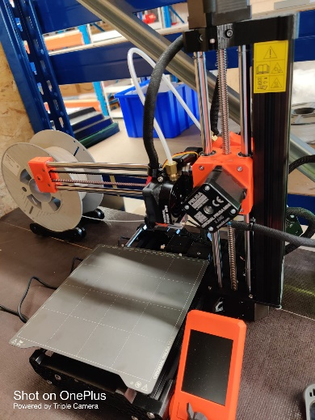
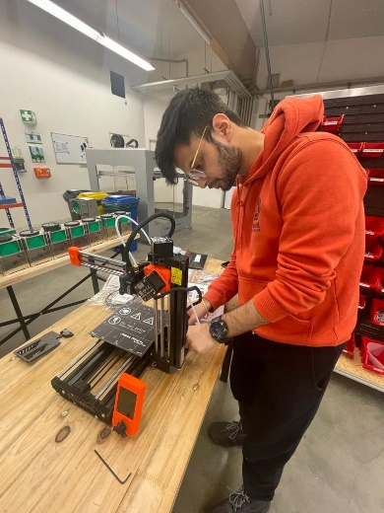
Figure 1: Assembling Prusa mini
Figure 2: Assembled3D Printer

16.03.2023
Our first assignment involved replacing a component in the air compressor with a 3D printed component. This was a minor task that had to be performed on four machines. Another small task we had to complete was attaching the legs of the air fan to its body, which also needed to be done four times.
The following task was to fix a 3D printer that was experiencing issues with shifting while printing. We researched online and found six potential causes, one of which was an abnormal stepper motor. We examined all the stepper motors using multimeter (pins: 1&3 and 4&6) and found that three out of four were functioning properly, but one was not. Unfortunately, we were unable to fully repair it as the company did not have a spare stepper motor of that specific size, and using a different size could result in torque problems.
We then moved on to learning about types of cables and the ways of crimping it. We familiarized ourselves with different cable types, how to strip the insulation correctly, and which crimpers to use. Once we had the basics down, we began our task, which involved creating wires of specific dimensions for various uses, such as stepper motors with cables measuring 4x0.5mm and a length of 150mm. These cables were intended for use in a laser cutting machine that would be sold soon. We also had to solder the motor cables and other cables.
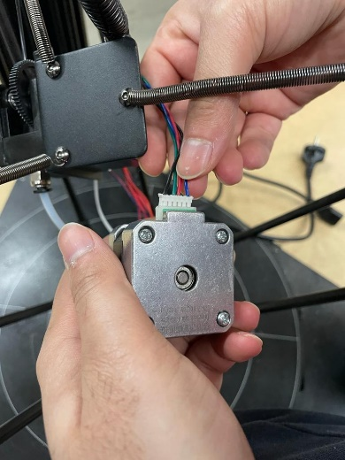

17.03.2023
Next day, we continued with the previous task of making cables for the laser cutting machines. We also learnt about the shrinking tube and how to use it.
